3D5- Assignment 2 report

Task 2 - Justification of quicksort design choices (pivot and partition scheme)

Partitioning Scheme: Lomuto

Compared to other schemes like Hoare partitioning, the Lomuto partitioning scheme is said to be easier to implement (1). Coding errors are also reduced when using this scheme as it requires fewer swaps.

Pivot Choice: Last Element in Array

While using the last element as the pivot can lead to worst-case performance [$O{\left(n\right)}^{2}$] in certain scenarios (2), the code's use of the Lomuto partitioning scheme mitigates this issue by making sure the pivot element is positioned correctly in the sorted sequence.

Task 3 - Include your results and comment on them in the report

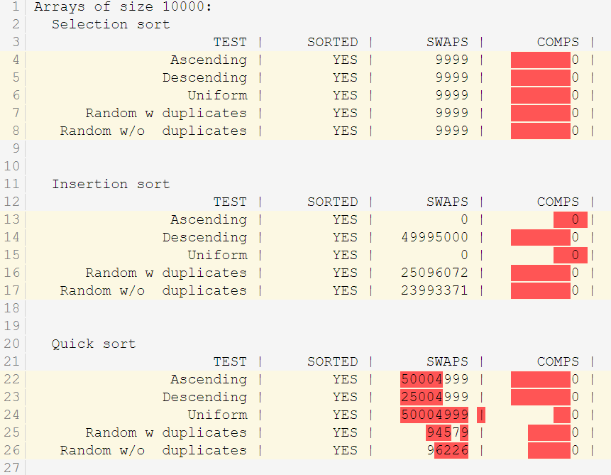

At first, my output showed zero for all comparison counts even though it correctly showed the expected swap counts. I had found out that the reason for this is that I had improperly implemented the necessary code to count for the number of comparisons in the wrong locations.

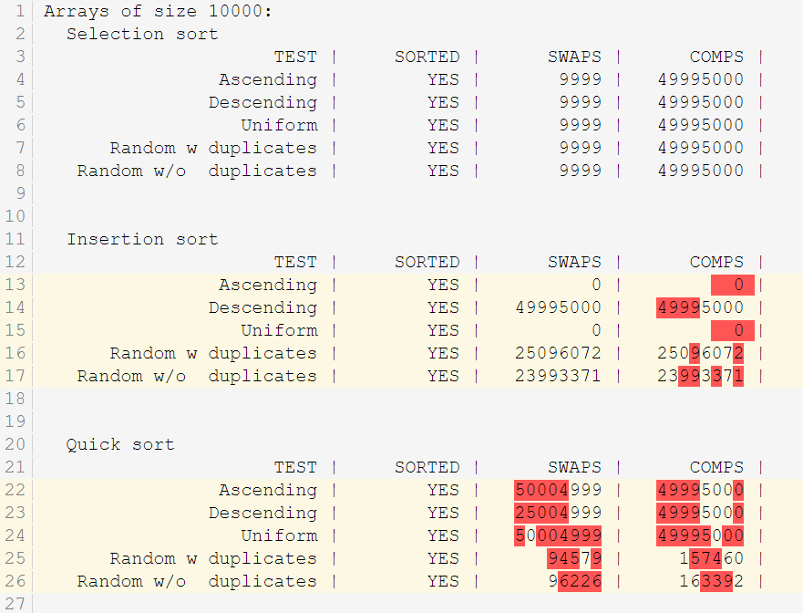

After implementing the comparison count code in the right locations it produced the output I had expected.

Task 4a – Include a short description of your approach and your results in the report

A structure is defined to store info about each game review, such as the title, system, score, and year. The dataset file "t4_ign.csv" is opened, and its contents are parsed line by line. The code checks each line to see if the year of the review falls between the earliest and latest review years (1996-2016) and if it has a score of 10.

After loading and filtering all relevant reviews (reviews with a score of 10 in the year range), a copy of these reviews is made, and each review is then sorted by year (using qsort()) (3). The sorted reviews are looped through to find the top 10 most popular games for each year. The output is organised and formatted to display these games, listing the title, system, and score.

Task 4b – Discuss how you would get the top 5 games for each of the last 20 years

As my code already gets the top games for each individual year, all I had to do to get the top 5 games change:

94| if (count <= 10) {

(in my void printTopGames() function)

to:

94| if (count <= 5) {

And would it output as intended.

**References:**

1. <https://www.geeksforgeeks.org/hoares-vs-lomuto-partition-scheme-quicksort/>
2. <https://en.wikipedia.org/wiki/Quicksort#:~:text=The%20shaded%20element%20is%20the,or%20arrays%20of%20identical%20elements>.
3. <https://www.geeksforgeeks.org/comparator-function-of-qsort-in-c/>

**TASK 4a OUTPUT**

|  |
| --- |
| -----------------------------------------------------------------------  -----Top 10 most popular games of the last 20 years (1996 to 2016)-----  -----------------------------------------------------------------------  Year: 1996  1. Title: Super Mario 64, System: Nintendo 64, Score: 10  2. Title: Wave Race 64, System: Nintendo 64, Score: 10  -----------------------------------------------------------------------  Year: 1997  1. Title: Final Fantasy VII, System: PlayStation, Score: 10  2. Title: GoldenEye 007, System: Nintendo 64, Score: 10  -----------------------------------------------------------------------  Year: 1998  1. Title: Banjo-Kazooie, System: Nintendo 64, Score: 10  2. Title: Colony Wars: Vengeance, System: PlayStation, Score: 10  3. Title: Gran Turismo [1998], System: PlayStation, Score: 10  4. Title: Half-Life, System: PC, Score: 10  5. Title: Metal Gear Solid, System: PlayStation, Score: 10  6. Title: Space Station Silicon Valley, System: Nintendo 64, Score: 10  7. Title: The Legend of Zelda: Ocarina of Time, System: Nintendo 64, Score: 10  8. Title: Xenogears, System: PlayStation, Score: 10  -----------------------------------------------------------------------  Year: 1999  1. Title: Ape Escape, System: PlayStation, Score: 10  2. Title: Checkered Flag, System: Lynx, Score: 10  3. Title: Driver, System: PlayStation, Score: 10  4. Title: Gran Turismo 2, System: PlayStation, Score: 10  5. Title: Homeworld, System: PC, Score: 10  6. Title: Joust, System: Lynx, Score: 10  7. Title: Mario Golf [Game Boy Color], System: Game Boy Color, Score: 10  8. Title: NFL 2K, System: Dreamcast, Score: 10  9. Title: Pokemon Blue Version, System: Game Boy, Score: 10  10. Title: Pokemon Red Version, System: Game Boy, Score: 10  -----------------------------------------------------------------------  Year: 2000  1. Title: Chrono Cross, System: PlayStation, Score: 10  2. Title: Crazy Taxi, System: Dreamcast, Score: 10  3. Title: Excitebike 64, System: Nintendo 64, Score: 10  4. Title: Jet Grind Radio, System: Dreamcast, Score: 10  5. Title: Magical Tetris Challenge, System: Game Boy Color, Score: 10  6. Title: Metal Gear Solid [2000], System: Game Boy Color, Score: 10  7. Title: NFL 2K1, System: Dreamcast, Score: 10  8. Title: Perfect Dark, System: Nintendo 64, Score: 10  9. Title: Pokemon Gold Version, System: Game Boy Color, Score: 10  10. Title: Pokemon Silver Version, System: Game Boy Color, Score: 10  -----------------------------------------------------------------------  Year: 2001  1. Title: Advance Wars, System: Game Boy Advance, Score: 10  2. Title: Black & White, System: PC, Score: 10  3. Title: Conker's Bad Fur Day, System: Nintendo 64, Score: 10  4. Title: Devil May Cry, System: PlayStation 2, Score: 10  5. Title: Dragon Warrior III, System: Game Boy Color, Score: 10  6. Title: Final Fantasy X, System: PlayStation 2, Score: 10  7. Title: Golden Sun, System: Game Boy Advance, Score: 10  8. Title: Gran Turismo 3 A-spec, System: PlayStation 2, Score: 10  9. Title: Grand Theft Auto III, System: PlayStation 2, Score: 10  10. Title: Halo: Combat Evolved, System: Xbox, Score: 10  -----------------------------------------------------------------------  Year: 2002  1. Title: Dance Dance Revolution Konamix, System: PlayStation, Score: 10  2. Title: Eternal Darkness: Sanity's Requiem, System: GameCube, Score: 10  3. Title: Grand Theft Auto: Vice City, System: PlayStation 2, Score: 10  4. Title: Metroid Fusion, System: Game Boy Advance, Score: 10  5. Title: Metroid Prime, System: GameCube, Score: 10  6. Title: The Legend of Zelda: A Link to the Past w/ the Four Swords, System: Game Boy Advance, Score: 10  7. Title: The Sims (Deluxe Edition), System: PC, Score: 10  8. Title: Tom Clancy's Splinter Cell, System: Xbox, Score: 10  9. Title: Tony Hawk's Pro Skater 3, System: Game Boy Advance, Score: 10  10. Title: Tony Hawk's Pro Skater 3, System: Xbox, Score: 10  -----------------------------------------------------------------------  Year: 2003  1. Title: Black & White (Platinum Pack), System: Macintosh, Score: 10  2. Title: Dell Magazines Crossword, System: Wireless, Score: 10  3. Title: F1 Challenge '99-'02, System: PC, Score: 10  4. Title: Final Fantasy X-2, System: PlayStation 2, Score: 10  5. Title: Fire Emblem, System: Game Boy Advance, Score: 10  6. Title: Grand Theft Auto Double Pack: Grand Theft Auto III & Grand Theft Auto: Vice City, System: PlayStation 2, Score: 10  7. Title: Jak II, System: PlayStation 2, Score: 10  8. Title: Lemonade Tycoon, System: Wireless, Score: 10  9. Title: Madden NFL 2004, System: PlayStation 2, Score: 10  10. Title: Pokemon Ruby Version, System: Game Boy Advance, Score: 10  -----------------------------------------------------------------------  Year: 2004  1. Title: Bejeweled Multiplayer, System: Wireless, Score: 10  2. Title: Burnout 3: Takedown, System: Xbox, Score: 10  3. Title: Grand Theft Auto: San Andreas, System: PlayStation 2, Score: 10  4. Title: Half-Life 2, System: PC, Score: 10  5. Title: Halo 2, System: Xbox, Score: 10  6. Title: Halo 2 (Limited Collector's Edition), System: Xbox, Score: 10  7. Title: Halo 4 (Game of the Year Edition), System: Xbox 360, Score: 10  8. Title: Jak 3, System: PlayStation 2, Score: 10  9. Title: Madden NFL 2005, System: Xbox, Score: 10  10. Title: Madden NFL 2005, System: PlayStation 2, Score: 10  -----------------------------------------------------------------------  Year: 2005  1. Title: Devil May Cry 3: Dante's Awakening, System: PlayStation 2, Score: 10  2. Title: Forza Motorsport, System: Xbox, Score: 10  3. Title: God of War [2005], System: PlayStation 2, Score: 10  4. Title: Gran Turismo 4, System: PlayStation 2, Score: 10  5. Title: Grand Theft Auto: San Andreas, System: Xbox, Score: 10  6. Title: Grand Theft Auto: San Andreas (Special Edition), System: PlayStation 2, Score: 10  7. Title: Jade Empire, System: Xbox, Score: 10  8. Title: Mario Kart DS, System: Nintendo DS, Score: 10  9. Title: Resident Evil 4, System: GameCube, Score: 10  10. Title: Resident Evil 4, System: PlayStation 2, Score: 10  -----------------------------------------------------------------------  Year: 2006  1. Title: Brothers in Arms 3D, System: Wireless, Score: 10  2. Title: Elite Beat Agents, System: Nintendo DS, Score: 10  3. Title: Final Fantasy XII, System: PlayStation 2, Score: 10  4. Title: Final Fantasy XII (Collector's Edition), System: PlayStation 2, Score: 10  5. Title: Guitar Hero II (Game Only Edition), System: PlayStation 2, Score: 10  6. Title: Mafia Wars: Yakuza, System: Wireless, Score: 10  7. Title: Metal Gear Solid 3: Subsistence, System: PlayStation 2, Score: 10  8. Title: Metal Gear Solid 3: Subsistence (Limited Edition), System: PlayStation 2, Score: 10  9. Title: New Super Mario Bros., System: Nintendo DS, Score: 10  10. Title: The Legend of Zelda: Twilight Princess, System: Wii, Score: 10  -----------------------------------------------------------------------  Year: 2007  1. Title: BioShock, System: Xbox 360, Score: 10  2. Title: BioShock, System: PC, Score: 10  3. Title: BioShock (Limited Edition), System: Xbox 360, Score: 10  4. Title: BioShock (Limited Edition), System: PC, Score: 10  5. Title: Castlevania: Symphony of the Night, System: PlayStation 3, Score: 10  6. Title: Castlevania: Symphony of the Night, System: PlayStation Portable, Score: 10  7. Title: Digital Chocolate Cafe, System: Wireless, Score: 10  8. Title: God of War II, System: PlayStation 2, Score: 10  9. Title: Halo 3, System: Xbox 360, Score: 10  10. Title: Halo 3 (Collector's Edition), System: Xbox 360, Score: 10  -----------------------------------------------------------------------  Year: 2008  1. Title: Fallout 3, System: Xbox 360, Score: 10  2. Title: Fallout 3, System: PC, Score: 10  3. Title: Fallout 3 (Collector's Edition), System: Xbox 360, Score: 10  4. Title: Fallout 3 (Collector's Edition), System: PC, Score: 10  5. Title: Fallout 3 (Survival Edition), System: Xbox 360, Score: 10  6. Title: Gears of War 2, System: Xbox 360, Score: 10  7. Title: Gears of War 2 (Limited Edition), System: Xbox 360, Score: 10  8. Title: Grand Theft Auto IV, System: Xbox 360, Score: 10  9. Title: Grand Theft Auto IV, System: PlayStation 3, Score: 10  10. Title: Grand Theft Auto IV (Special Edition), System: Xbox 360, Score: 10  -----------------------------------------------------------------------  Year: 2009  1. Title: Bayonetta, System: Xbox 360, Score: 10  2. Title: Call of Duty: Modern Warfare 2, System: PC, Score: 10  3. Title: Call of Duty: Modern Warfare 2, System: PlayStation 3, Score: 10  4. Title: Call of Duty: Modern Warfare 2, System: Xbox 360, Score: 10  5. Title: Call of Duty: Modern Warfare 2 (Hardened Edition), System: PlayStation 3, Score: 10  6. Title: Call of Duty: Modern Warfare 2 (Hardened Edition), System: PlayStation 3, Score: 10  7. Title: Call of Duty: Modern Warfare 2 (Prestige Edition), System: Xbox 360, Score: 10  8. Title: Call of Duty: Modern Warfare 2 (Prestige Edition), System: PlayStation 3, Score: 10  9. Title: Empire: Total War, System: PC, Score: 10  10. Title: Empire: Total War (Special Forces Edition), System: PC, Score: 10  -----------------------------------------------------------------------  Year: 2010  1. Title: Battlefield: Bad Company 2 -- Vietnam, System: Xbox 360, Score: 10  2. Title: Battlefield: Bad Company 2 -- Vietnam, System: PC, Score: 10  3. Title: God of War: Ghost of Sparta, System: PlayStation Portable, Score: 10  4. Title: Halo: Reach, System: Xbox 360, Score: 10  5. Title: Halo: Reach (Legendary Edition), System: Xbox 360, Score: 10  6. Title: Halo: Reach (Limited Edition), System: Xbox 360, Score: 10  7. Title: Joe Danger, System: PlayStation 3, Score: 10  8. Title: Mass Effect 2, System: PC, Score: 10  9. Title: Mass Effect 2, System: Xbox 360, Score: 10  10. Title: Mass Effect 2 (Collector's Edition), System: PC, Score: 10  -----------------------------------------------------------------------  Year: 2011  1. Title: Batman: Arkham City, System: Xbox 360, Score: 10  2. Title: Batman: Arkham City, System: PlayStation 3, Score: 10  3. Title: Batman: Arkham City, System: PC, Score: 10  4. Title: Chrono Trigger, System: Wii, Score: 10  5. Title: FIFA Soccer 12, System: Xbox 360, Score: 10  6. Title: FIFA Soccer 12, System: PlayStation 3, Score: 10  7. Title: Final Fantasy III (SNES), System: Wii, Score: 10  8. Title: Forza Motorsport 4, System: Xbox 360, Score: 10  9. Title: Gesundheit, System: iPhone, Score: 10  10. Title: Groove Coaster, System: iPhone, Score: 10  -----------------------------------------------------------------------  Year: 2012  1. Title: Batman: Arkham City -- Armored Edition, System: Wii U, Score: 10  2. Title: Crashmo, System: Nintendo 3DS, Score: 10  3. Title: Diablo III, System: Macintosh, Score: 10  4. Title: Diablo III, System: PC, Score: 10  5. Title: Fez, System: Xbox 360, Score: 10  6. Title: Great Big War Game, System: iPhone, Score: 10  7. Title: Halo 4, System: Xbox 360, Score: 10  8. Title: Halo 4 (Limited Edition), System: Xbox 360, Score: 10  9. Title: Mass Effect 3, System: PC, Score: 10  10. Title: Mass Effect 3, System: Xbox 360, Score: 10  -----------------------------------------------------------------------  Year: 2013  1. Title: Animal Crossing: New Leaf, System: Nintendo 3DS, Score: 10  2. Title: BioShock Infinite, System: PC, Score: 10  3. Title: Device 6, System: iPhone, Score: 10  4. Title: Fez, System: PC, Score: 10  5. Title: Fez, System: PlayStation 3, Score: 10  6. Title: Fez, System: PlayStation Vita, Score: 10  7. Title: Fez, System: PlayStation 4, Score: 10  8. Title: Fire Emblem Awakening, System: Nintendo 3DS, Score: 10  9. Title: Flower, System: PlayStation 4, Score: 10  10. Title: Gone Home, System: Macintosh, Score: 10  -----------------------------------------------------------------------  Year: 2014  1. Title: Bayonetta 2, System: Wii U, Score: 10  2. Title: Broken Age: Act 1, System: iPhone, Score: 10  3. Title: Broken Age: Act 1, System: PC, Score: 10  4. Title: FTL: Faster Than Light, System: iPad, Score: 10  5. Title: FTL: Faster Than Light, System: PC, Score: 10  6. Title: Grand Theft Auto V, System: PlayStation 4, Score: 10  7. Title: Grand Theft Auto V, System: Xbox One, Score: 10  8. Title: Minecraft, System: PlayStation 3, Score: 10  9. Title: Minecraft, System: PlayStation Vita, Score: 10  10. Title: Minecraft, System: PlayStation 4, Score: 10  -----------------------------------------------------------------------  Year: 2015  1. Title: Fallout 4, System: PC, Score: 10  2. Title: Fallout 4, System: PlayStation 4, Score: 10  3. Title: Fallout 4, System: Xbox One, Score: 10  4. Title: Grand Theft Auto V, System: PC, Score: 10  5. Title: Metal Gear Solid V: The Phantom Pain, System: Xbox One, Score: 10  6. Title: Metal Gear Solid V: The Phantom Pain, System: PlayStation 4, Score: 10  7. Title: Metal Gear Solid V: The Phantom Pain, System: PC, Score: 10  8. Title: Pro Evolution Soccer 2016, System: PlayStation 4, Score: 10  -----------------------------------------------------------------------  Year: 2016  1. Title: Dark Souls III, System: PlayStation 4, Score: 10  2. Title: Dark Souls III, System: PC, Score: 10  3. Title: Fire Emblem Fates: Conquest, System: Nintendo 3DS, Score: 10  4. Title: Fire Emblem Fates: Revelation, System: Nintendo 3DS, Score: 10  5. Title: Forza Horizon 3, System: Xbox One, Score: 10  6. Title: Inside, System: PlayStation 4, Score: 10  7. Title: Inside, System: Xbox One, Score: 10  8. Title: Inside, System: PC, Score: 10  9. Title: Odin Sphere Leifthrasir, System: PlayStation 4, Score: 10  10. Title: Odin Sphere Leifthrasir, System: PlayStation Vita, Score: 10 |